BSc (Hons) Computing Course 2024/25
Level 6 Production Project
Name: Navin Kumar Purbey | Student I.D : 77356793
Course: BSc (Hons) Computing | Supervisor’s Name: Rohit Pandey
Final Project Individual Aim & Objectives
Project Title:
Predictive Analysis And Visualization of HealthCare Market Trends

Project Aim:
This Project goals are to analyze healthcare Market Data using Predictive analysis and visualization techniques. By using historical Datasets, it seeks to forecast healthcare trends, optimize resource allocation, and improve decision-making for healthcare industry stakeholders.

Objectives of my Project:
The main objectives of my project are: -
- Develop the Predictive Analysis model to forecast Healthcare Market Trends.
- Create the Visualization Dashboard to present healthcare data insight.
- Data Collection, Cleaning, and Preprocessing to ensure data accuracy.
- Identify patterns and Correlations to provide useful insights.
- Access and optimize predictive models to enhance accuracy
- By successfully testing and validating.
- Add real-time data to the dashboard.
- Evaluate Predictive models to find the best fit.
- Making A Beautiful WebApp for Forecast the Healthcare Visualization.

The Sub Objectives of my project are: -
- Offer data-driven recommendations to guide healthcare decisions.

Specification of my Product:
Specifications are categorized into Functional and Non-Functional described with the MoSCoW method.
Functional Requirements | MoSCoW
Develop the Predictive Model for trend analysis | M
Create an interactive Dashboard for visualization. | M
Creating the WebApp for Forecast Visualization | M
Identify real-time data integration. | S
Export and reporting functionality | C
User Access control and role base data views | C
Develop the Mobile Friendly version of the dashboard | W
Implement AI-driven insights for advanced analytics. | W

Non-Functionality Requirements | MoSCoW
High Performance and Quick Data Processing | M
Secure data Handling and Encryption | M
User-friendly Interface for easy navigation | M
Easy maintenance and Future upgrades system | S
High availability and system uptime | C
Scalable architecture to handle large datasets | S
Implement multi-language support for all users. | W

Research:
According to (Raghupathi et al.,2010), the healthcare industry has historically produced a lot of data due to patient care, record keeping, compliance, and regulatory obligations. To forecast illness patterns, expand outreach initiatives, and improve the disease management, healthcare analytics—the field those studies both historical and contemporary the healthcare data—is essential (Hoda and Mondal, 2023). Growing complexity, and the inefficiency, poor quality, and growing prices are some of the problems that accompany its expansion (Cortada et al., 2012). To solve the issue, the majority of previous studies on hospital readmissions included scoring systems, logistic regression, and cohort studies (Ross et al., 2008). A 2011 evaluation study by the Department of the Veterans Affairs found that current risk-prediction models of hospital readmission often perform to the poorly (Kansagara et al., 2011). Data scientists have created several XAI (Explainable Artificial Intelligence) techniques to handle this kind of issue and offer comprehensible details on ML models (Adadi and Berrada, 2018).
Evaluation:
As defined in the Project Specification and objective the success of this project will be measured by prediction visualization dashboard and accuracy data. Model outputs will be evaluated through performance metrics such as R^2, and RMSE. Healthcare Professionals will evaluate the dashboard's clarity and usefulness in terms of decision-making. Machine learning models will be constantly tested in the project environment based on real-time data to improve reliability. The measured project's ability to spot trends data enhances resources planning and produces data actionable insights that lead to efficiency and quality in the Healthcare Market and will be long-term success as they are continuously improve and adapt.
Project Planning & Methodology
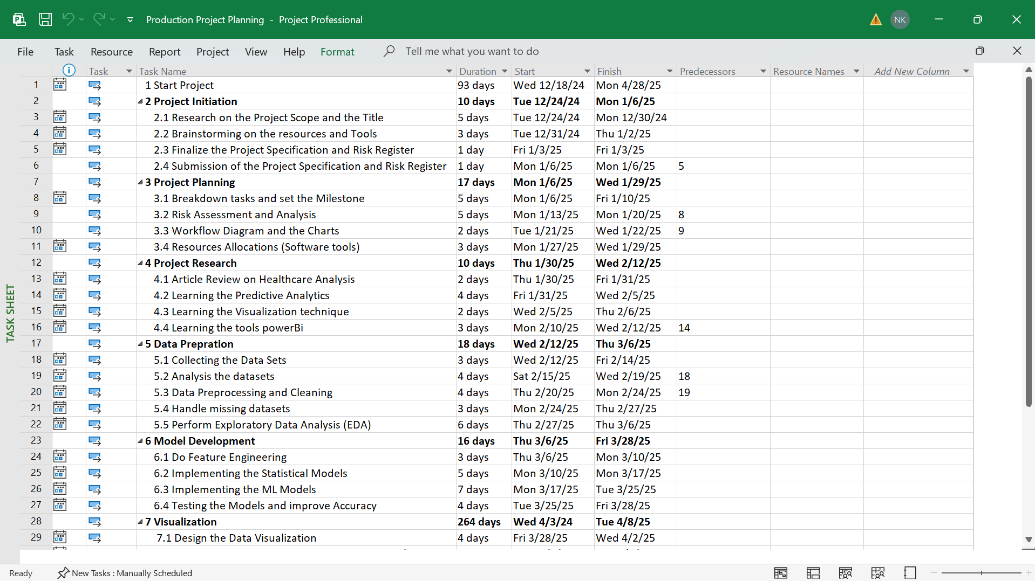
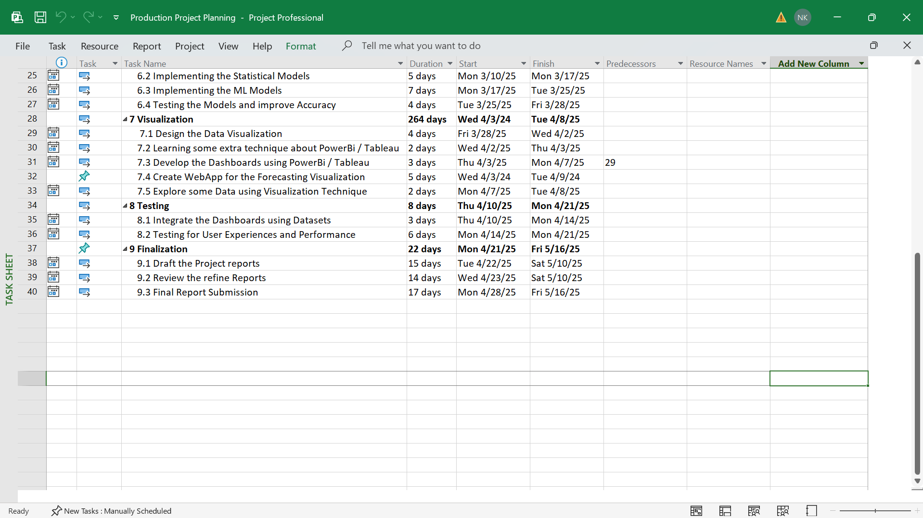

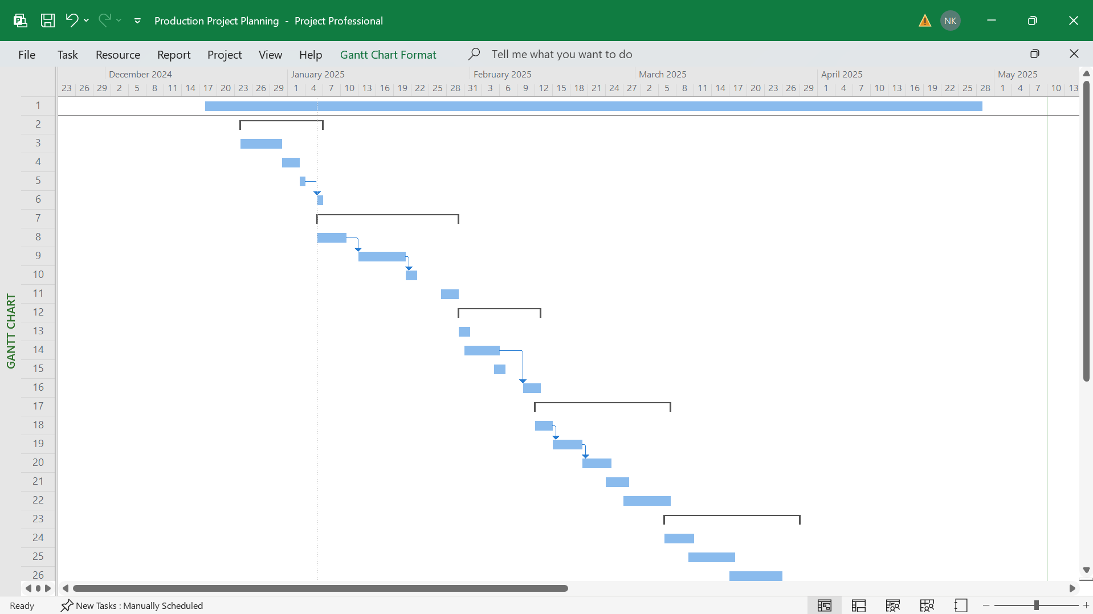
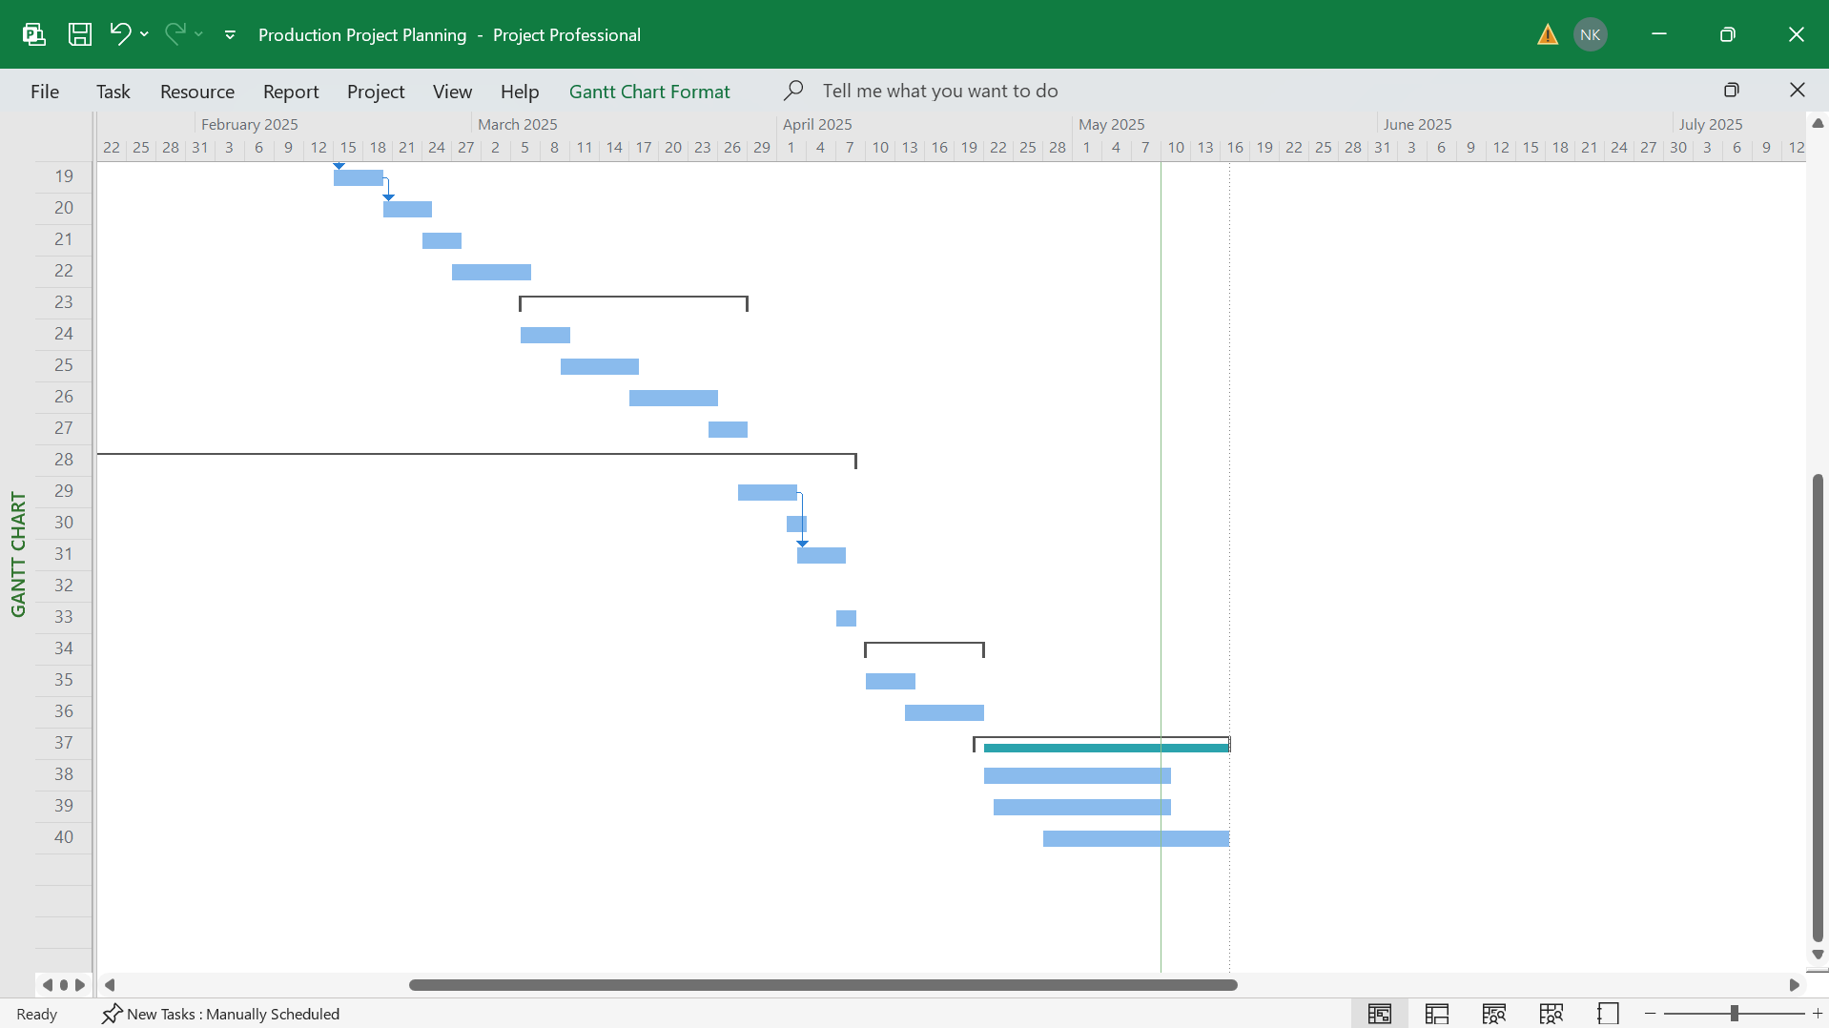

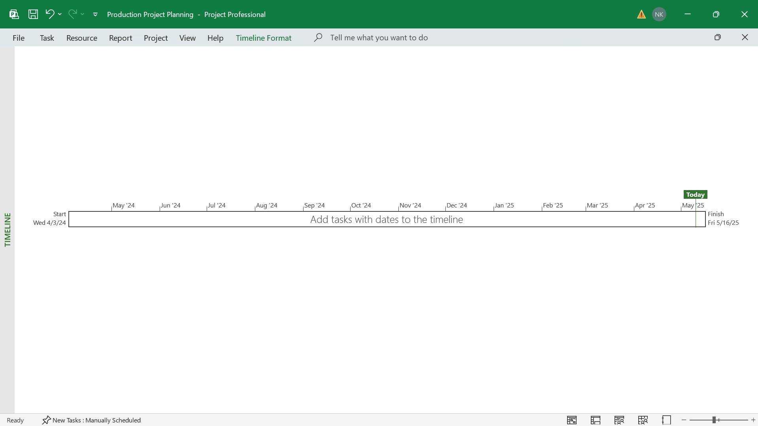

Methodology:
The Study is Concern with understanding and exploring conceptual depth of Predictive Analysis and Visualization of Healthcare Market Trends, supported by relevant facts and data. The project involves gathering data from multiple sources of Healthcare Industry datasets without applying control over variables. Data is extracted from scientific Articles and healthcare reports. Comparative Analysis of various ML models and visualization tools to determine the predictive framework and tools such as Python, PowerBi, and SQL are evaluated to enhance the accuracy of Healthcare Market Trends Predictions and ensure the data-driven insights are communicated. The Project follows the Agile methodology and approach to ensure adaptability to evolving data and aligning the final with Healthcare Industry needs.

Resources
All the software is free and open-source.
Software:
- Python with (Pandas and NumPy, scikit-learn, TensorFlow)
- Matplotlib
- Seaborn, Plotly
- PowerBI or Tableau
- SQL (MongoDB)
- Database
- Statical Analysis
- ML – with Models
- Jupyter Notebook
- Excel, Word, PowerPoint, Project
- Git/GitHub
- Visual Studio Code or PyCharm
- React (for deployment)
- Windows 11
- Web Browser – Google Chrome
- Grammarly – for Correction of the sentences
- Draw.io Software – for Drawing Diagrams
- QSEE Superlite – for Use case Diagram etc…

Hardware:
- ASUS ZenBook Laptop
- AMD RYZEN 5500 Series
Human Resource
I am working on my Project with the following people.
Name: Navin Kumar Purbey | Role:  Module Leader  Supervisor
Initial Bibliography

- Raghupathi W: Data Mining in Health Care. Healthcare Informatics: Improving Efficiency and Productivity. Edited by: Kudyba S. 2010, Taylor & Francis, 211-223.
- S.A. Hoda, A.C. Mondal Studies on Multi-Criteria Decision-Making Based Healthcare Systems Using Machine Learning Journal of Artificial Intelligence and Technology (2023)
- Cortada, J.W.; Gordon, D.; Lenihan, B. The Value of Analytics in Healthcare; Report No.: GBE03476-USEN-00; IBM Institute for Business Value: Armonk, NY, USA, 2012. [Google Scholar]
- Ross, J., Mulvey, G., Stauffer, B., and et al (2008). Statistical models and patient predictors of readmission for heart failure: A systematic review. Archives of Internal Medicine, 168(13):1371–1386.
- Kansagara, D., Englander, H., and Salanitro, A. (2011). Risk prediction models for hospital readmission: A systematic review. JAMA, 306(15):1688–1698.
- Adadi A., Berrada M. Peeking inside the black-box: A survey on explainable artificial intelligence (XAI) IEEE Access, 6 (2018), pp. 52138-52160
- Kawaler, E., Cobian, A., Peissig, P., Cross, D., Yale, S., Craven, M., 2012. Learning to predict post-hospitalization VTE risk from EHR data. In: AMIA Annual Symp. Proc. vol. 2012. American Medical Informatics Association. p. 436-445.

Risk Register
ID | Risk | Risk Description | Likelihood | Impact | Severity | Owner | Mitigation | Status
1 | Inaccuracy of data | Errors in the Healthcare datasets leading to incorrect ML models | Medium | High | High | Navin Kumar Purbey | Validate the data sets conducted through Data EDA and back up the alternative data sources. | Open
2 | Model Performance | Predictive Models Under Performance on New Datasets | Medium | High | Low | Navin Kumar Purbey | Performance of the cross-validation and tune model parameters and exploring the Model technique. | Open
3 | Stakeholders Feedback Delay | Late feedback may hamper the progress of the project | Low | Medium | Medium | Navin Kumar Purbey | Schedule the regular hurry reviews for early feedback. | Open
4 | Data Security and Privacy | Breach of sensitive Healthcare data/database | High | High | Low | Navin Kumar Purbey | Encrypt the Datasets follow the GDPR guidelines and give the Limit access. Obtain the necessary ethical approval if required. | Open
5 | Tools/Software Malfunction | PowerBi issues, Python or MySql tools | Medium | Medium | Low | Navin Kumar Purbey | Keeps Backup and Software and conducts regular testing. | Open
6 | Project Timeline Overrun | Project Milestone delayed due to unplanned cause. | Medium | High | Medium | Navin Kumar Purbey | First Develop the realistic Project schedule and Using Agile, set buffer time for critical tasks. | Open
7 | Lack of technical Experience | ML models are very vast so insufficient Knowledge of complex models | Low | Medium | Medium | Navin Kumar Purbey | Engaging Continuously, Learning the Important Tools, and seeing the different types of Experiences/Experts if needed. | Open
8 | Requirement Changes | Healthcare Trends are evolving with time so changing project requirement | Low | Medium | High | Navin Kumar Purbey | Using the Agile framework to help change iteratively. | Open

